Digital Image Analysis Tutorial 10
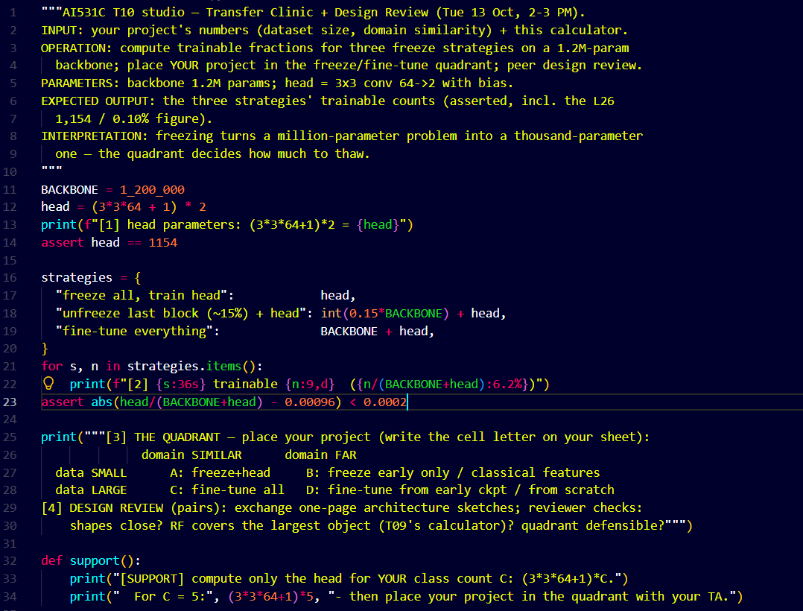
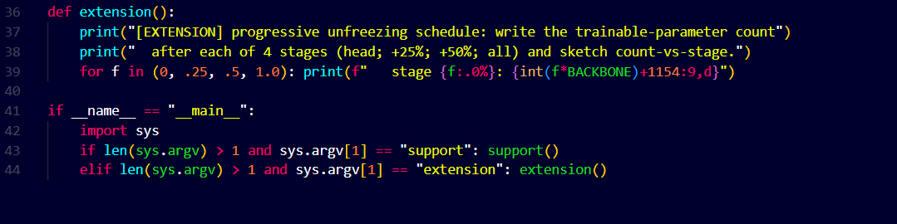
Output:
